# Ice Cream Recipes Made Simple

## David Williams

## WDD 130

## Overview

### Purpose

To teach people how they can make their own ice cream at home. Help them evaluate the pros and cons of different recipes. And help them save money.

### Audience

Moms, Party Hosting, Homesteaders, and Cooks

## Branding

### Website Logo



## Style Guide

### Color Palette

|  |  |  |  |
| --- | --- | --- | --- |
| **Header** | **Main** | **Paragraph Boxes** | **Footer** |
| Strawberry #FF6F91 | **Vinilla #FFF3E0** | Mint #A8E6CF  Blue #B3E5GC  Purple #D7BDE2 | Cocolate #8B5E3C |

### Typography

#### Heading Font: “Delius”

#### Paragraph Font: “Crushed”

#### (Embedded Link for HTML)

#### <link rel="preconnect" href="[https://fonts.googleapis.com](https://fonts.googleapis.com/)">

#### <link rel="preconnect" href="https://fonts.gstatic.com" crossorigin>

#### <link href="https://fonts.googleapis.com/css2?family=Crushed&family=Road+Rage&display=swap" rel="stylesheet">

#### Navigation

Home Vanilla Chocolate Salted Caramel Mint

#### Footer

|  |  |  |  |  |
| --- | --- | --- | --- | --- |
| Class | Client | Lead Dev | 1 Junior Dev | 2 Junior Dev |
| WWD 130 | David Williams | Jared Gudmundson | Aaron Fowler | Benjamin Smith |

**Home Page**

# H1: Discover Fun, Fresh, Creative Ice Cream Recipes

### ****Tips for Perfect Ice Cream****

* **Prevent Ice Crystals** – Keep your mixture cold before churning, use enough sugar to lower the freezing point, and store finished ice cream in shallow, airtight containers to reduce thaw-and-freeze cycles.
* **Add Mix-Ins the Right Way** – Fold in ingredients like chocolate chips, cookie chunks, or fruit pieces during the last 1–2 minutes of churning so they stay evenly distributed and don’t sink or turn mushy.
* **Get Rich Flavor Without Heavy Fat** – Use ingredients like condensed milk, egg yolks, or a small amount of cornstarch to boost creaminess, and add strong natural flavors—such as vanilla bean paste or espresso concentrate—to keep taste bold without extra cream.
* **Choose the Right Tools** – A basic ice cream machine improves texture dramatically, silicone spatulas help scrape every bit of mixture cleanly, and insulated storage tubs prevent ice buildup and preserve flavor longer.

# At the bottom display these pictures. Make them grow and shake when the mouse is hovering over them.

# And make them links to the recipe pages.

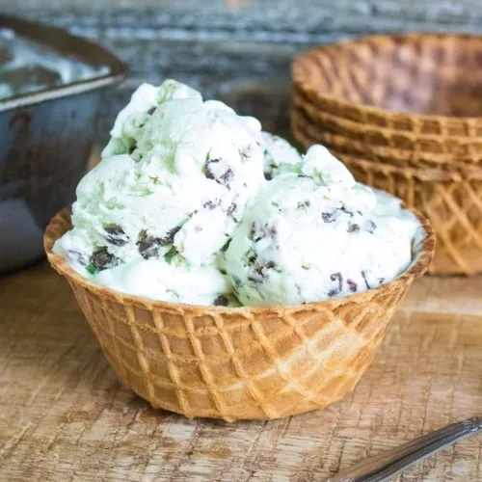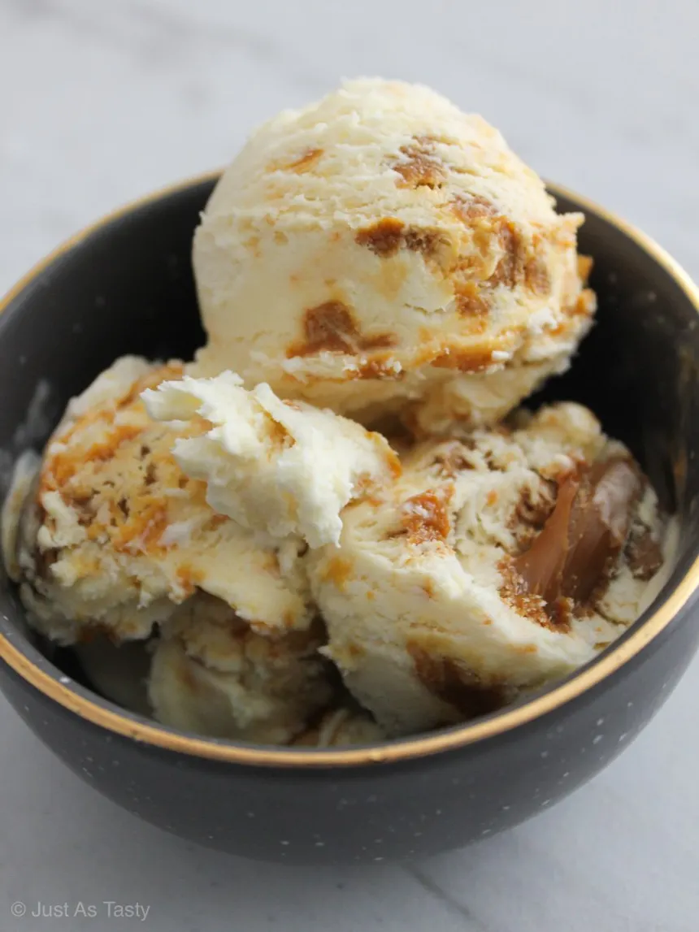

**Vanilla**

# 

# 

# ****H1: Ultimate Vanilla Ice Cream (Custard-Style)****

### ****Ingredients:****

**Custard Base:**

* 2 cups heavy cream
* 1 cup whole milk
* 3/4 cup granulated sugar
* 1 vanilla bean or 1.5 tbsp high-quality vanilla extract
* 4 large egg yolks
* Pinch of salt

### ****Instructions:****

#### ****1. Heat the dairy****

* In a saucepan, combine **heavy cream, milk, half the sugar, and salt**.
* If using a **vanilla bean**, split it, scrape the seeds into the pot, and add the pod too.
* Heat over medium until just steaming — **do not boil**.

#### ****2. Whisk the yolks****

* In a separate bowl, whisk the **egg yolks** with the remaining sugar until pale and slightly thick.

#### ****3. Temper the eggs****

* Slowly pour a little warm cream mixture into the yolks while whisking constantly.
* Gradually add more until the yolks are warm, then pour everything back into the saucepan.

#### ****4. Cook the custard****

* Cook over medium-low heat, stirring constantly with a spatula.
* Stop when it thickens enough to coat the back of the spoon (**around 170–175°F / 77–80°C**).
* Remove from heat immediately.

#### ****5. Add the vanilla****

* If using extract, add it now (after heating).
* Remove the vanilla bean pod if used.

#### ****6. Chill the mixture****

* Strain the custard through a fine sieve.
* Refrigerate for **at least 4 hours**, ideally overnight. Cold custard = smoother ice cream.

#### ****7. Churn****

* Pour into your ice cream maker and churn according to the manufacturer instructions.

#### ****8. Freeze****

* Transfer to a container and freeze for **4 hours** or until firm.

**Chocolate**

### 

### ****H1: Rich Chocolate Ice Cream****

#### ****Ingredients:****

**Ice Cream Base:**

* 2 cups heavy cream
* 1 cup whole milk
* 3/4 cup granulated sugar
* 1/2 cup unsweetened cocoa powder
* 4 oz dark chocolate, chopped
* 1 tsp vanilla extract
* Pinch of salt

**Optional Add-ins:**

* Chocolate chips, fudge swirls, or chopped nuts

#### ****Instructions:****

1. **Mix dry ingredients:**
   * In a medium saucepan, whisk together sugar, cocoa powder, and salt.
2. **Add liquids:**
   * Slowly whisk in milk and cream until smooth. Heat over medium heat until just warm (do not boil).
3. **Melt the chocolate:**
   * Remove from heat and stir in chopped dark chocolate until fully melted and smooth.
4. **Add vanilla and chill:**
   * Stir in vanilla extract. Let the mixture cool to room temperature, then refrigerate for 2–4 hours until fully chilled.
5. **Churn the ice cream:**
   * Pour the chilled mixture into an ice cream maker and churn according to the manufacturer’s instructions.
6. **Freeze:**
   * Transfer to a freezer-safe container and freeze for at least 4 hours before serving.
7. **Serve:**
   * Scoop into bowls or cones, optionally topping with chocolate chips, fudge, or nuts.

**Salted Caramel**

### 

### ****H1: Salted Caramel Pretzel Ice Cream****

#### ****Ingredients:****

**For the ice cream base:**

* 2 cups heavy cream
* 1 cup whole milk
* 3/4 cup sugar
* 1 tbsp vanilla extract
* Pinch of salt

**For the caramel swirl:**

* 1 cup granulated sugar
* 6 tbsp butter, cubed
* 1/2 cup heavy cream
* 1 tsp sea salt

**Add-ins:**

* 1 cup crushed pretzels (small chunks)

#### ****Instructions:****

1. **Make the ice cream base:**
   * In a saucepan, combine milk, sugar, and salt over medium heat. Stir until sugar dissolves.
   * Remove from heat, stir in heavy cream and vanilla. Chill in the fridge for at least 2 hours.
2. **Make the caramel:**
   * In a separate pan, melt sugar over medium heat until it turns amber.
   * Add butter carefully (it will bubble!) and stir until melted.
   * Slowly add cream and stir until smooth. Remove from heat and add sea salt. Let cool.
3. **Churn the ice cream:**
   * Pour the chilled ice cream base into an ice cream maker and churn according to the manufacturer’s instructions.
4. **Assemble:**
   * Layer ice cream, drizzle caramel, and sprinkle crushed pretzels. Repeat to create swirls.
   * Freeze for at least 4 hours or until firm.
5. **Serve:**
   * Scoop, maybe add extra caramel drizzle on top, and enjoy!

**Mint**

### 

### ****H1: Creamy Mint Ice Cream****

#### ****Ingredients:****

**Ice Cream Base:**

* 2 cups heavy cream
* 1 cup whole milk
* 3/4 cup granulated sugar
* 1 tsp peppermint extract (adjust to taste)
* Pinch of salt
* Green food coloring (optional, for that minty look)

**Optional Add-ins:**

* 1/2 cup mini chocolate chips or chopped dark chocolate
* Crushed peppermint candies for extra crunch

#### ****Instructions:****

1. **Mix the base:**
   * In a medium bowl, whisk together sugar, salt, milk, and cream until sugar is dissolved.
2. **Add flavor and color:**
   * Stir in peppermint extract and a few drops of green food coloring (if using).
3. **Chill:**
   * Refrigerate the mixture for 2–4 hours until well chilled.
4. **Churn:**
   * Pour the chilled mixture into an ice cream maker and churn according to the manufacturer’s instructions.
5. **Add mix-ins:**
   * In the last few minutes of churning, fold in chocolate chips or crushed peppermint candies.
6. **Freeze:**
   * Transfer to a freezer-safe container and freeze for at least 4 hours to firm up.
7. **Serve:**
   * Scoop into bowls or cones and enjoy a cool, minty treat!

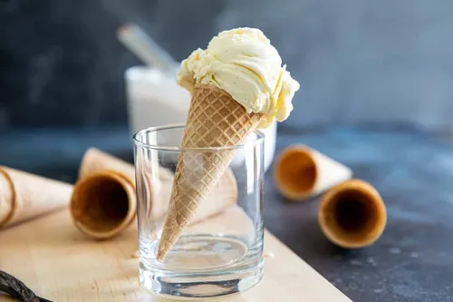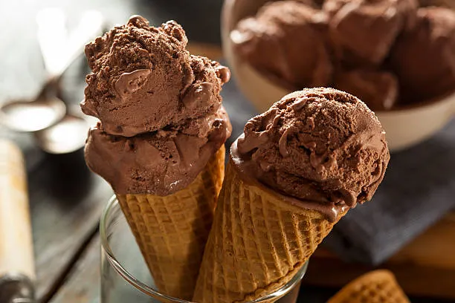**Home Page Wire Frame**

Discover Fun, Fresh, Creative Ice Cream Recipes

Logo

Ice Cream Recipes Made Simple

Home

Vanilla

Chocolate

Salted Caramel

Mint

Class

WWD 130

Client

David Williams

Lead Dev

Jared Gudmundson

1 Junior Dev

Aaron Fowler

2 Junior Dev

Benjamin Smith

Logo

Browse Recipes

Tips for Perfect Ice Cream

\***Prevent Ice Crystals** – Keep your mixture cold before churning, use enough sugar to lower

the freezing point, and store finished ice cream in shallow, airtight containers to reduce

thaw-and-freeze cycles.

*ect...

*

**Content Pages Wire Frame**

Logo

Vanilla Recipe

Home

Vanilla

Chocolate

Salted Caramel

Mint

Class

WWD 130

Client

David Williams

Lead Dev

Jared Gudmundson

1 Junior Dev

Aaron Fowler

2 Junior Dev

Benjamin Smith

Instructions

1. Heat the dairy

* (some steps will take up a lot of space thats why the should go here)

* Dairy in pot

* Pot on stove

* Turn stove on low for 4 minutes

2. Yoke the Eggs

* Crack eggs into boll

* Whisk

# 

Ingredents

Custard Base

* Eggs

* Dairy

* Ice

* Vanilla Extranct

H1: Ultimate Vanilla Ice Cream (Custard-Style)